

LAB REPORT 04

SUBMITTED TO : MR. MUBASHIR IQBAL
SUBMITTED BY: AHMED SALEEM RANA
REG ID: 24-CYS-023
SECTION : B
COURSE TITLE: ARTIFACIAL INTEELLIGENCE LAB

HITEC UNIVERSITY, TAXILA CANTT
TASK 01
Employee Management:
• Create a Person class with attributes/variables “name” and “age”.
• Create a Job class with attributes/variables “designation” and “salary”.
• Create an Employee class that inherent the above both classes
• Implement a method to display employee details
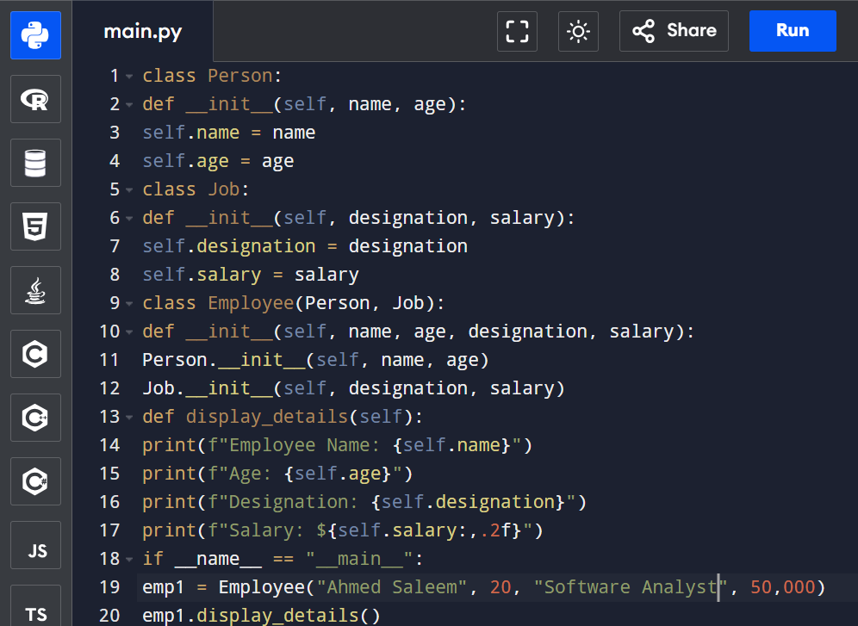
INPUT:
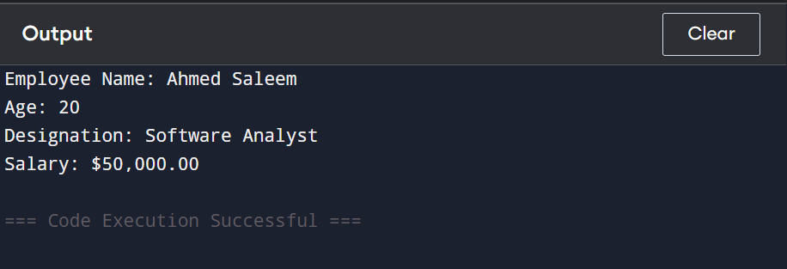
OUTPUT:

EXPLANATION:
This program demonstrates a simple example of combining data from multiple classes. The Person class stores personal details like name and age, and the Job class stores job-related information such as designation and salary. The Employee class combines both sets of data and displays them using the show_details() method. The program creates a person named “Ali,” aged 25, who works as a “Manager” with a salary of 50,000, and then prints all these details together.

TASK 02

Write a Python class named Circle constructed by a radius and two methods which will compute the area and the perimeter of a circle.
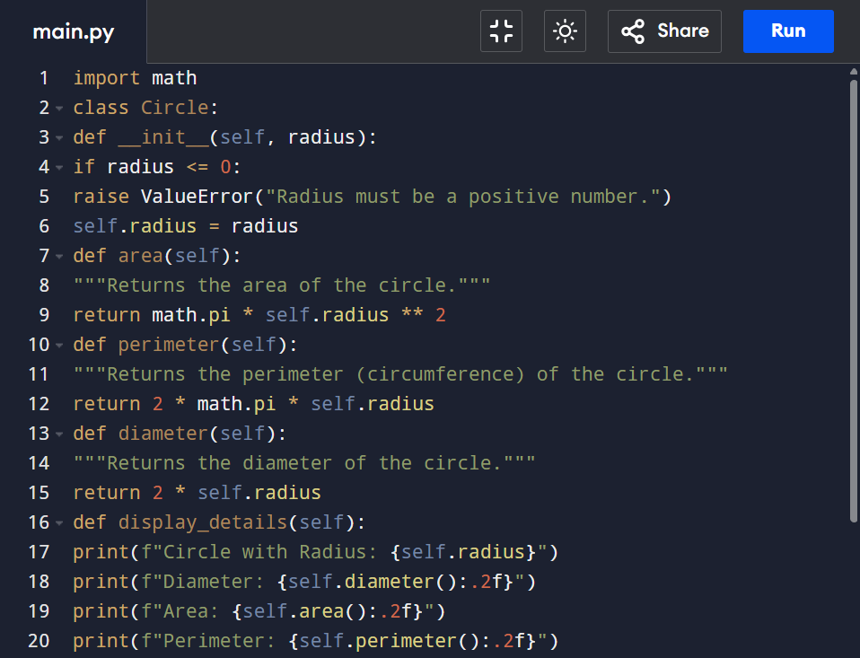
INPUT:
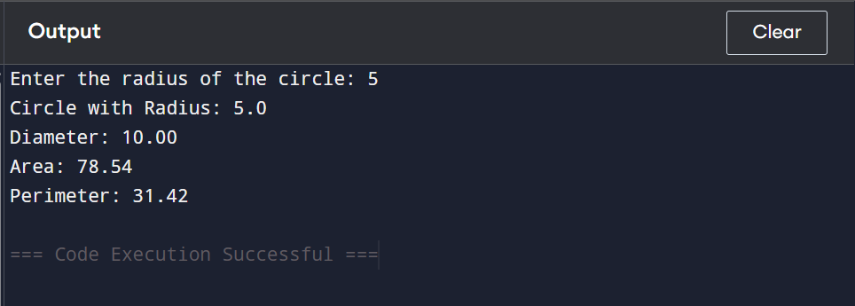
OUTPUT:
EXPLANATION:
This program defines a Circle class to calculate the area and perimeter of a circle. The class has two methods: area(r) returns the area using the formula 3.14 * r * r, and perimeter(r) returns the perimeter using 2 * 3.14 * r. The user enters the radius, and the program calls both methods to display the calculated area and perimeter of the circle.
TASK 03
Write a Python class to implement pow(x, n). Do not use built-in math.pow() function for this code. Also handle this code for all positive as well as negative numbers.
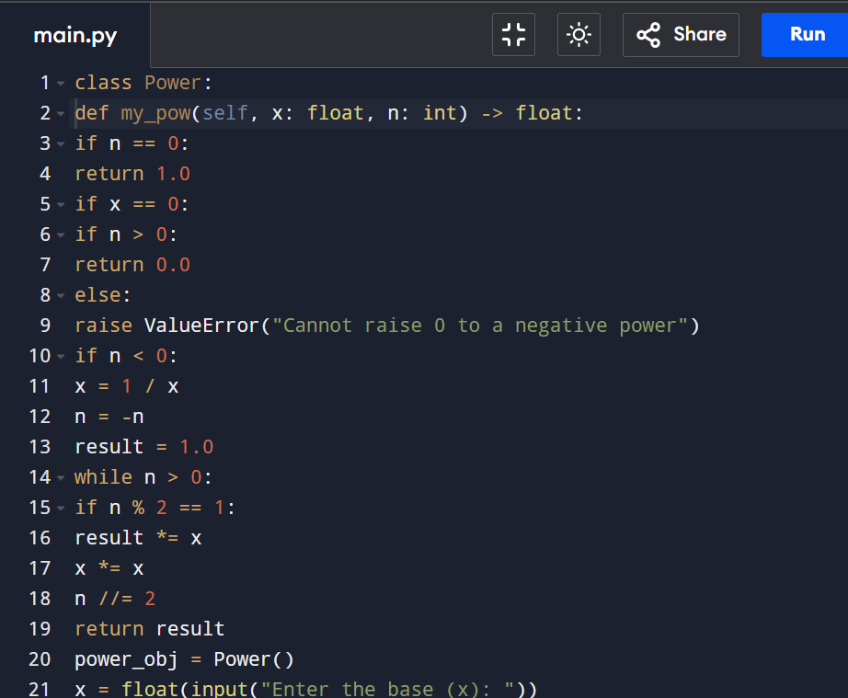
INPUT:
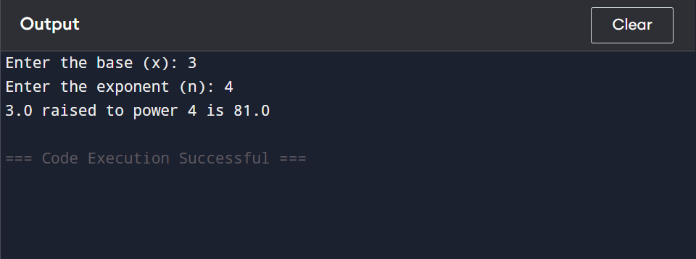
OUTPUT:
EXPLANATION:
This Python program finds the power of a number without using math.pow(). The Power class has a method calculate(x, n) that multiplies the base x by itself n times. If n is negative, it returns the reciprocal, and if n is zero, it returns 1. The user enters the base and exponent, and the program shows the result.

TASK 04
Write a Python code for the following figure

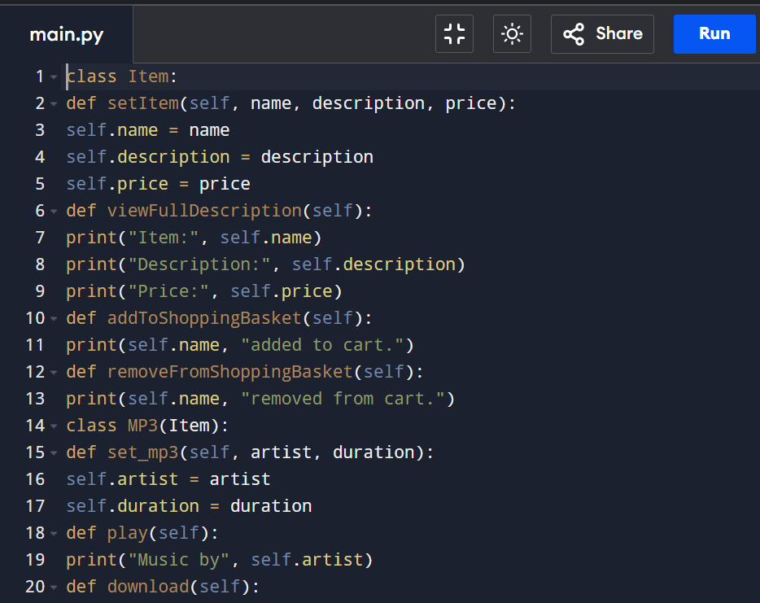
INPUT:
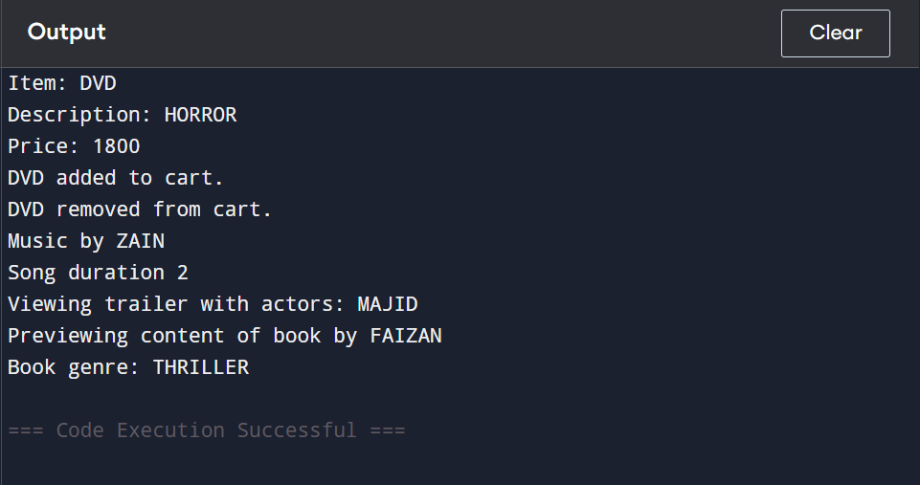
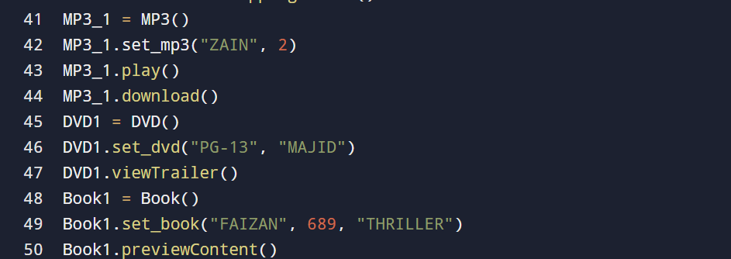
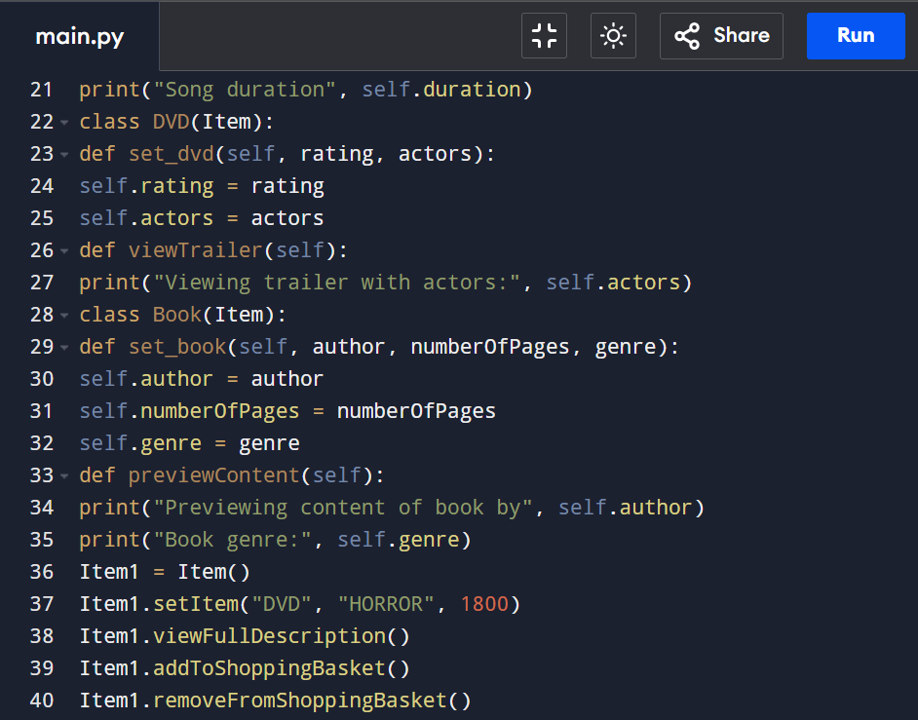
OUTPUT:
EXPLANATION:
This program shows inheritance using classes. The base class Item holds common details like name, description, and price, while the subclasses MP3, DVD, and Book add their own attributes and functions such as play, view trailer, and preview content. It demonstrates how subclasses can extend the features of a parent class to create specific item types.
CONCLUSION:
In conclusion, these programs show how Python can be used to solve simple problems using classes, functions, loops, and conditions. They help understand basic concepts like inheritance, calculations, and data handling in an easy and clear way.
GITHUB REPOSITORY LINK:

